./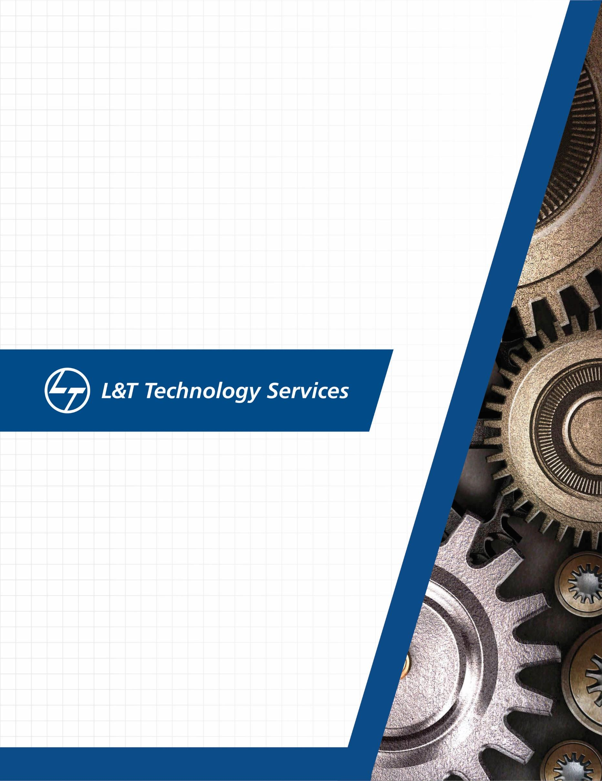



Version Number:

Team Members :

Team No:

Module: Model Based System Engineering

**A MINI PROJECT DOCUMENT**

**ON**

“EMPLOYEE AND INTERN RECORD SYSTEM”

SUBMITTED BY :- DIMANTH G S

CANDIDATE ID :-  104929

|  |  |  |  |  |  |
| --- | --- | --- | --- | --- | --- |
| **Ver. Rel. No.** | **Release Date** | **Prepared. By** | **Reviewed By** | **Approved By** | **Remarks/Revision Details** |
| 1 | 22-09-2020 | Dimanth G S |  |  |  |
| 2 | 23-09-2020 | Dimanth G S |  |  |  |
|  |  |  |  |  |  |
|  |  |  |  |  |  |
|  |  |  |  |  |  |

**Document History**

# 

**Table of contents**

|  |  |
| --- | --- |
| 1 | Introduction |
| 2 | Problem statement |
| 3 | Description |
| 4 | Design |
| 5 | Requirements |
| 6 | Test plan |
| 7 | Test case |
| 8 | Outputs |
| 9 | Conclusion |

**Introduction:**

The project is titled as “**Employee and intern record system**”. It is a system used to manage a record of the employees and interns in an organization or management. The project mainly focuses on file handling for a given set of details of people in an organization. The details can be modified as per the requirements by making few changes in the program.

The project gives us information about the record, which can be extracted and can be used later. The project focuses on adding, modifying and deleting the details of the person of the organization. We can keep records of an employee such as name, mail ID, salary etc. It helps to maintain a proper record of a person working in the organization.

Throughout the project, the focus is kept on adding a record, modifying a record and deleting a record.

The project is very useful for those who want to know about a record system. This project is a console application without graphics compiled in Code::Blocks using GCC compiler. The source code for this project is easy to understand.

**Problem statement:**

This study will support and manage records for a given organization. Also, the students will be able to develop a system program using Codeblocks software for design of record system in response to the problems in the current manual operations, services are enumerated below.

* Lack of Details: There were a lot of details of a person working in a organization which are not well-accomodated/saved.
* Slow retrieval of Data: The viewing of records and returning of records were not well-established.
* Separation of the data: The data provided was not well separated, which makes it difficult to identify and retrieve data of person working in organization.
* Addition of more data: Sufficient data was not added, it is required sufficient information about a person in an organization.
* Unique identification: It was observed that the employee or intern working in the organization didn’t have a unique identification, which would help in tracking down the person working in the organization.

**Description :**

The main features of this project include file handling operations; we will learn how to add, list, modify and delete data to/from file. The functions used in this project are basically manipulate file handling and data structures.

Currently, listed below are the only features that make up this project, we can add new features as we like to make this project a better one.

* Add record
* List record
* Modify record
* Delete record

**Design :**

Identify

Employee or Intern

Employee

Delete Record

Modify Record

List Record

Add Record

List the details of the employees

Enter ID

Enter ID

Attributes:

Name

Age

ID

Mail

Salary

Organization

Delete the details of the employee

Enter the details

Intern

Delete Record

Modify Record

List Record

Add Record

List the details of the interns

Enter ID

Enter ID

Attributes:

Name

Age

ID

Mail

Stipend

Organization

Delete the details of the employee

Enter the details

**Requirements :**

**Software Requirements:**

* GNU GCC Compiler
* Code::Blocks IDE v20.03

**Operating System:**

* Windows OS

**Test Plan :**

The resources here required are GCC compiler or any IDE of C to develop and build the code.

1. To check if the program menu displays all options correctly
2. To check if the options are given for the selection.
3. To check if the selected option direct towards correct path.
4. To check if the options are selected as per requirement.
5. To check if the user select to add record, attributes are added.
6. To check if the user choses to list the record, the window displays the records.
7. To check if the user choses to modify record, the terminal should accept ID.

Based on the given ID, the changes are made

1. To check if the user choses to delete the record, based on given ID, it should be able to delete the details of the person of the organization.
2. To check if the user can close the application.

**Test Cases :**

Testing involves the design of test cases that validate that the internal program logic is functioning properly.

1. Test case 1 : To check if the main screen is showing.
   * + 1. Employee Data
       2. Intern Data
       3. Exit

Expected output : if the user enter correct option , it directs towards correct path. If invalid option is chosen, it waits for the user to enter correct option.

1. Test case 2 : If option 1 is chosen, the window directs towards another screen where given below options should be displayed.

1. Add Record

2. List Record

3. Modify Record

4. Delete Record

5. Exit

Expected output : Enter Particular number for which menu to go for example for add record press number 1 and then press enter key.

1. Test case 3 : For add record it waits for the user to enter name, age, ID, mail ID, Salary, Organization.

Expected output : The record is added and asks if the user want to enter add record of another person with (y/n).

1. Test case 4 : If the user wants to add record of another person again, “y” is chosen.

Expected output : After entering “y” , the details are asked for user to add details of another another person

1. Test case 5 : If the user wants to exit, “n” is pressed .

Expected output : The program comes back to Test case 2.

1. Test case 6 : If the user wants a list of the records entered .Enter option 2

Expected output: Output displays the list and details of the records entered.

1. Test case 7 : If the user wants to modify the details of a person. Enter option 3.

Expected output: The program should ask for ID of the employee to be modified.

If the ID matches, details to be entered is asked from the user.

1. Test case 8 : If the user wants to delete the details of a person. Enter option 4.

Expected output: The program should ask for ID of the employee to be deleted.

1. Test case 9 : If the user wants to exit. Enter option 5.

Expected output: the program should exit.

1. Test case 10: If option 2 is pressed on main screen should direct towards the details of the intern

And above test cases can be repeated.

**Expected outputs:**

The expected outcomes is development and maintain of data that it provided. The record System is used in which user can maintain data of employees and interns working in an organization. The system should be able to add, list , modify and delete record if necessary.

**Conclusion:**

* The record system allows the user to store the person’s details.
* This software allows storing the details of all the data related to file.
* User friendly and efficient management of records